National Army Museum
7-14yrs Family Backpack Brief
February 2017

1. Introduction

The National Army Museum is working to transform its family offer. As a further step in this process, the Museum is looking to appoint a suitably qualified and experienced consultant to develop the content of a family backpack for the Museum.

Families represent an important growth segment within the Museum’s audience development strategy and their needs have been briefed into the creation of the Museum’s new visitor offer with content and activities designed for our two distinct family audience segments: Learning Families and Kids’ First families:

- Learning Families - Mixed age groups, wanting an educational trip for children
- Kids’ First Families - Mixed age groups, wanting fun and social trip for children and whole family.

We very much see this project as adding a further layer of engagement and fun to the Museum experience for our younger visitors. The backpack should have a range of activities that appeal to families with children aged 7-14 and foster a sense of exploration and fun. The activities should encourage families to explore all galleries and interact with our innovative new content and exhibits.

The design and fulfilment of the pack/trail will be the responsibility of design company, Easy Tiger Creative, who have been appointed under separate contract to develop an initial family identity for the new Museum.

It should be noted that a separate backpack is being developed for children aged 0-7. The design and delivery of this pack with be aligned to the Museum’s new Play Base early years learning facility, also designed by East Tiger Creative.

We are looking for a consultant with a proven understanding of family learning and engagement in museums. You will need to demonstrate an awareness of the challenges inherent in balancing the need to deliver engaging and fun opportunities within a national museum context. Ideally, you will also have an affinity for our purpose and our story.

This document explains the project in more detail. The Museum is looking to work closely with a consultant to develop and deliver the resource in a creative and impactful way that is relevant and accessible to the target audience.

If you are interested in tendering for the project, this document provides the following information:

- The National Army Museum
- Audience profile – current and future
- Scope of services
- Budget and timeline

2. The National Army Museum

2.1 A New Museum

In spring 2017, a new national Museum will open in London after a three-year closure. The Museum’s vision is bold. To use its rich historical and developing contemporary collections to foster people’s awareness, understanding and knowledge of the British Army, its soldiers and legacy. And through this exploration, encourage debate about an institution that is little understood but is intrinsically part of our democratic society and enables us to live with the freedoms we enjoy everyday.

2.2 Building for the Future

This new Museum has been created through the auspices of the Building for the Future (BFTF) project. Set to cost £23.75million, the project has been funded by a Heritage Lottery Fund grant of £11.5m, with the remainder covered by fundraising carried out by the Museum.

The project is realising the wholesale transformation of the Museum’s offer onsite, offsite and online, across seven main work streams.

1. A new brand and marque
During 2014-15 the Museum worked to create a new brand model to help direct and inform the development of the new Museum. It has influenced every aspect of the new Museum, from permanent displays, to interior design to signage to the extent that the new building physically embodies the new brand, helping to transform the Museum from a dark and traditional place to a modern, bright, and relevant Museum fit for the 21st century.

2. A wholly new visitor experience. A major restructure of the building has created: five new thematic galleries – Soldier, Army, Battle, Society, Insight; a new 500m² temporary exhibition space; a new three-room learning centre; a new early years learning facility – Play Base; a new research centre and archive; new café; new shop; and new boardroom. All are being realised within a building designed to create a more welcoming and engaging physical experience and supported by a fresh approach to public programming (see below).

3. New programmes for learning and outreach. The closure of the Museum has provided unprecedented opportunities to pilot new approaches to delivering our learning purpose and to test how the Museum can extend its reach whilst also providing the depth and breadth of offer required of a national museum. On opening the Museum will offer relevant, thought-provoking and challenging opportunities to engage with the Collection and our stories through community engagement and curation, new learning services aimed at early years, schools, families, adults and lifelong learners, and new a public programme that seeks to encourage active participation and debate in a wide range of topics from military history to present day conflicts and world geopolitics. It is a place that will spark conversations.

4. New working models of service delivery and public engagement. The project has enabled the Museum to review its structure, the ways it fulfils its purpose, the services it offers and its enabling and supporting systems and processes. As the project moves into delivery phase, new teams, processes, services and training are being put in place to deliver an audience-focused, commercially sustainable and more goal driven organisation. This is facilitated by new working models that focus on process and cross-departmental and cross-divisional collaboration.

5. A sharper focus on generating income. The new visitor experience whilst creating a more welcoming and engaging physical experience has also sought to ensure a focus on facilities and activities to drive earned income. In order to achieve this, commercial spaces and the overall offer within the Museum have been designed to be visible, enticing and reflect the growing expectations of Museum audiences.

6. Better conservation of and access to the Collection. The project has enabled the conservation of thousands of objects for the new displays. In addition, it has enabled a significant programme of digitisation that will provide easier and greater access to the Museum’s national archives online that through accompanying cataloguing and external partnerships, will provide a modern, flexible and customer-centred online enquiry services, aimed at meeting the needs of a broad range of researchers from the school pupil to the family historian to the expert academic.

7. Going digital. Digital transformation underpins much of the new Museum’s work. Whilst attention is necessarily focused on what needs to be done to deliver the modern services expected of a 21st century museum, the creation of the Museum’s new website is seen as the first step in a medium- to long-term digital journey that will see a wholesale review, modernisation and streamlining of the Museum’s systems as digital becomes central not only to realising efficiencies but to delivering a world-class national museum service, locally, nationally and internationally. Digital is central to the Museum achieving a greater sphere of influence and impact and in developing brand awareness.

2.3 The new galleries

The new Museum will feature five thematic galleries and a temporary exhibition space that highlight our world-class Collection in innovative ways, and encourage visitors to explore the history of the British Army and its influence on our world today.

- Soldier Gallery
This gallery connects the visitor to the soldier as an individual; utterly human, capable of courage and cowardice, virtue and vice
- Battle Gallery
Battles are the ultimate and most dramatic test of an Army. Visitors can explore how the British experience of fighting battles has been shaped through four chronological eras. They will be able to explore the transformative effects of technology, as well as the enduring importance of the human factor in the experience of battles
- Army Gallery
The Army gallery explores what the army is and why we have one. The gallery tells the story of the creation of the British Armies and shows them in relation to events worldwide, as well as engaging people in the true and dynamic character of this fast changing and responsive organisation.
- Society Gallery
The Society gallery explores the relationship between British society and the Army. It explores the ways in which civilians encounter the Army, such as face-to-face, taking action, through popular culture, and being encouraged to remember and commemorate the fallen.
- Insight Gallery
Insight explores the impact of the Army around the world, enabling visitors to scrutinise objects and archives and community perspectives on the Collection.

3. The National Army Museum’s Family Audience

3.1 The Museum’s audiences before the redevelopment

Before closure, the Museum had a total onsite audience of around 250,000 visitors per annum. Families made up about 43% of this total, with Kids’ Zone, the 0-7s play area, being very popular.

In 2010-11, NAM attracted 88,000 Learning Families visits and 9,000 Kids First Families visits. Our total Families audience for that year was 97,000. These two family audience segments break down as follows:

Kids First Families | 4% | Mixed age groups, wanting fun and social trip for children and whole family | Ease of access, child friendly facilities and activities, services for all ages, engaging exhibitions, accessible interpretation
Learning Families | 39% | Mixed age groups, wanting an educational trip for children | As above: but better able to direct visit than Kids Firsts

3.2 The Museum’s audience objectives after redevelopment

During the closure period, the Museum has delivered fun, family-friendly outreach events and activities in the local area and beyond. After re-opening, we have ambitious targets to significantly increase our existing Kids First and Learning Families audiences, especially families with children 7-14 years. We also aim to increase the ethnic, cultural, and social diversity of our family audience. Our annual family targets are as follows:

Year | 2017-18 | 2021-22 | 2025-26
Kids First Families | 13,000 | 16,000 | 16,000
Learning Families | 114,000 | 140,000 | 140,000
Total Families | 127,000 | 156,000 | 156,000

The new 7-14 backpack will form an important part of our new family offer, which also includes backpacks for 0-7 families, interactive galleries, modern amenities, a family-focused events programme, and Play Base.

5 Scope of services

5.1 Overview

NAM is looking to appoint a creative consultant who can use their expertise to develop and brief a pack of dynamic and diverse activities that encourage exploration and fun for families with children aged 7-14 visiting the Museum.

Our new brand model underpins the approach to our subject matter and themes, so we expect the backpack to support these principles. Please see Appendix A for more information.

Appointed consultant will be expected to deliver on time, and within the stated budget, the scope of services as defined outlined below.

5.2 Specifications

NAM requires:
- The appointed consultant to plan and produce all content for a backpack of activities for families with children aged 7-14, and liaise with Easy Tiger Creative in the design development process.
- The appointed consultant to prepare a design brief for Easy Tiger Creative to design and fulfill the activity backpacks.
- The activities appeal to 7-14 year olds, encourage intergenerational family learning, and foster connections with the Museum’s exhibits and stories.
- The activities engage multiple learning styles, such as visual, social, logical, and tactile.
- The backpack to encourage visits to all five galleries.
- The activities are practical within a gallery space and sustainable for long-term use by the museum.
- The activities are robust and extensive enough to reward multiple visits and uses.
- The appointed consultant to liaise with the NAM project manager regularly to ensure content is in line with museum objectives and themes.

5.3 Requirements

All elements in the proposed project are to be:

- Compliant with current Equality Act legislation.
- In line with NAM’s corporate ethos and strategic objectives as outlined in this document.
- In line with the audience development aspirations as outlined in this document.
- Where materials are recommended, these should be subject to Health and Safety, sustainability, and durability testing.
- Where materials are recommended these should be open to value engineering.

6 Budget and timetable

6.1 Budget

The Museum has allocated a guideline budget for this activity of £3,500-7,000.

Quoted fees must include all of the following:

- Professional fees
- Development costs
- Travel and expenses
- An estimate of any contingency
- All third party fees
- Report, printing and presentation costs
- Costs for prototype development and testing

The fees should indicate if they include or exclude VAT.

6.2 Project Team

- Project Manager: Ashleigh Hibbins, Learning Producer
- Project Sponsor: Genevieve Adkins, Assistant Director - Public Programmes

6.3 Timetable

The timetable for the project will be:

Activity | Deadline
Issue of brief | w/c 13 February 2017
Tender deadline | 24 February 2017
Appointment | 24 February 2017
Commissioning meeting | w/c 27 February 2017
Delivery of content and design brief | 30 March 2017
Development of all content and liaison with design agency to design and deliver the activity backpacks | 01 April-30 June

6.4 Tender Process

6.4.1 Response to the brief

Responses to the brief should demonstrate:
- A clear methodology statement for the development and delivery of the Services
- An outline work plan
- Your relevant experience in this area
- Cost plan detailing the tasks and staff responsibilities, daily and hourly rates and expenses
- Your ability to meet the deadline.

6.4.2 Fee

The Fee is to be a fixed sum for the provision of all Services as outlined in the Scope of Services.

The Fee is to include all expenses. This will include travel costs, accommodation, disbursements, reports and all other expenses and costs required in the provision of the Service. The fee should exclude VAT at the prevailing rate.

6.4.3 Instalment Payments

Provide a suggested fee drawdown schedule in your response. NAM reserves the right to amend any suggested drawdown schedule.

6.4.4 Insurance

Please provide copies of up-to-date insurance - NAM requires Public
Liability with a minimum of £1 million and Professional Indemnity Insurance to the value of £1 million.

6.4.5 References

Provide reference details of two recent contracts that are relevant to this project.

6.2 Tender Submission

Tenders should comprise 1x hard copy and 1 x electronic on DVD/memory stick of all tender content as outlined below:

- 7-14yrs Family Backpack tender proposal
- The completed Form of Tender (Appendix B)
- The completed Certificate of Bona-Fide Tender (Appendix C)
- Any other information that is required to clarify the tender.

6.2 Tender Return

Tenders must be submitted no later than 1200hrs on 24 February 2017 in a plain envelope labelled only with the address below and clearly marked “Tender – 7-14yrs Family Backpack”. No other marks or wording (including pre-paid franked stamps), which might indicate the identity of the sender, shall appear on the envelope containing the tender.

The tender shall be submitted to:

Mr John Foster
National Army Museum
Royal Hospital Road
Chelsea
London SW3 4HT

Tenders can also be returned via email at the above date and time to: jfoster@nam.ac.uk. The subject of the email should state “Tender - 7-14yrs Family Backpack”. Any electronic tenders received before this date will be rejected.

Tenders are to remain open for acceptance for a period of 30 days.

6.3 Tendering Costs

NAM will not be responsible for or pay for any costs or expenses that are incurred by any tendering consultant in preparing and submitting their tender.

6.4 Contract Award Criteria

The tender board may consist of the following NAM representatives:

- Assistant Director (Public Programmes)
- Acting Head of Learning
- Learning Producer: Secondary

Tenders will be assessed on the following criteria:

- Methodology 20%
- Qualifications and Experience 30%
- Project Team and Resourcing 30%
- Budget 20%

Tenders will be awarded on the absolute discretion of the Board of the Museum, in accordance with internal policies and statutory regulations. NAM is not required to accept the lowest priced tender.

The decision will be final and binding, no correspondence will be entered into.

6.5 Tender programme

The key dates in relation to this tender exercise are detailed below.
Activity | Deadline
Issue of brief | w/c 13 February 2017
Tender deadline | 24 February 2017
Appointment | 24 February 2017
Commissioning meeting | w/c 27 February 2017

The above programme is indicative of the Museum’s timescales. However, the project sits within the BftF Master Programme and may be subject to alteration.

The forward programme will be developed with the appointed consultant.

11.7 Enquiries

Any enquiries arising must be submitted in writing via email to:

Ashley Hibbins, Learning Producer, National Army Museum
Email: ahibbins@nam.ac.uk

Enquiries will be answered within two working days.

Appendices

Appendix A – Brand Model

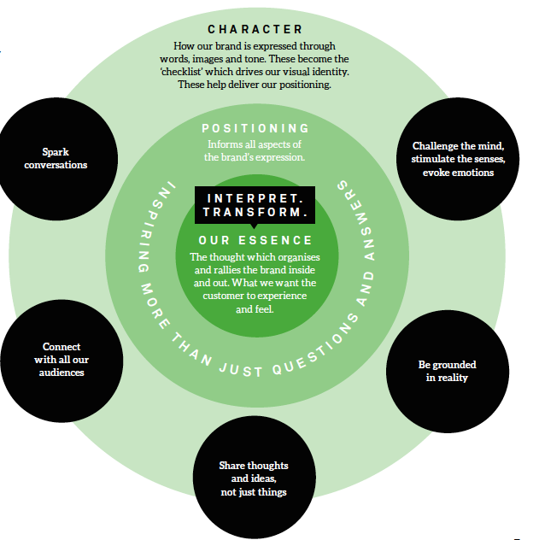
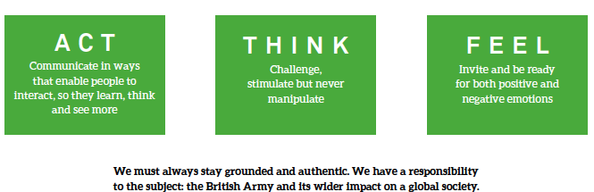

APPENDIX B: FORM OF TENDER

Tender for: National Army Museum 7-14yrs Family Backpack

To: The Council and Director of the National Army Museum

Sirs,

I/We the undersigned, having examined the enclosed tender documents and Appendices, do hereby offer to execute and complete in accordance with the said documents the works described therein:

For the sum as listed in the attached document:

Tenderer Reference:

I/We hereby affirm our agreement to enter into a contract with the Council of the National Army Museum for the due performance of the Works in the form described by the above said documents.

I/We have completed the Certificate of Bona-Fide Tender included in this document.

I/We understand that the Trustees are not bound to accept the lowest or any tender which may be received nor or responsible for any cost incurred in the preparation of any tender.

I/We declare that this offer is to remain open for acceptance for a period of 60 days from the date fixed for the receipt of tenders.

Signed: ____________________________________________________

In the capacity of

Duly authorised to sign the tender on behalf of:

Date:

APPENDIX C: CERTIFICATE OF BONA-FIDE TENDER

Tender for: National Army Museum Website Project

I/We certify that this is a bona-fide tender and that I/we have not fixed or adjusted the amount thereof by or under in accordance with any agreement or arrangement with any other person.

I/We also certify that I/We have not done and I/We undertake that I/we will not do at any time any of the following acts:

- Communicate to a person other than the person calling for these tenders the amount or approximate amount of the proposed tender except where the disclosure, in confidence, of such amount(s) was necessary to obtain insurance premium quotations required for the preparation of the tender.

- Enter into any agreement or arrangement with any other person that he shall refrain from tendering or as to the amount of any tender to be submitted;

- Offer or pay or give or agree to pay or give any sum of money or valuable consideration directly or indirectly to any person for doing or having done or causing or have caused to be done in relation to any other tender or proposed tender for the said work any act or thing of the sort described above.

In this certificate the word “person” includes any person and any body, association, corporate or un-incorporated; and “any agreement” includes such transaction, formal or informal, and whether legally binding or not.

Signed: ____________________________________________________

In the capacity of

Duly authorised to sign the tender on behalf of:

Date:

